
Licensed Real Estate Broker
3300 Route 343 (East Main Street) PO Box 15 Amenia, New York 12501-0015
TEL: 845.373.8555 FAX: 845.373.9850 email: havensre@optonline.net
www.havensre.com
Filled with Space and Style! Great Views!
16 Deer Run Rd, Town of North East
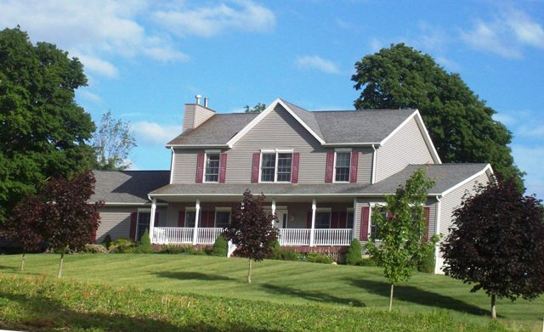
$SOLD

Style: Colonial Bedrooms: 3 Bathrooms: 2 Full 1 Half

Stories: 2 Living Room: 17’ x 15’ w gas FP

Square Feet: 2,514 Kitchen: 18’ x 13’

Lot Size: 3.26 acres Dining Room: 13’ x 11’
Year Built: 2006 Master Bedroom: 19’ x 14’ w Master Bath
Taxes: $8,424 (2014) Bedroom: 16' x 10'
Exterior: Vinyl Bedroom: 13’ x 12’
Roof: Asphalt Shingle Bedroom: 15’ x 14’
Electric: 200 Amps, circuit breakers Full Basement Attached 2 Car Garage
Heat: BBHW oil Central Air: 2nd Fl, Master Br
Mid-Hudson MLS: #329887 CCND MLS: #97988
Just 8 years young with sensational views in a surprisingly private setting. Amenities: First Floor Master Bedroom and Master Bath, spacious rooms gracefully balanced by a flowing layout, the largeness of the kitchen is impressive, hardwood floors, 3 second floor bedrooms featuring generous sizes and stunning view out of each window. This is a prime rural area in Eastern Dutchess County. The Village of Millerton is just minutes away and very convenient to the Harlem Valley Rail Trail, Golf, State Parks, Metro North Hiking and Skiing. There are several private schools that are reasonably close.
The real estate data for sale on this website is subject to errors, omissions, changes, and withdrawal without notice. Information deemed to be reliable but not guaranteed.

